**Chapter 6**

**Vector Calculus**

**6.1 Vector Fields**

**Section Exercises**

1. The domain of vector field  is a set of points  in a plane, and the range of **F** is a set of *what* in the plane?

Answer: Vectors

**For the following exercises, determine whether the statement is *true* or *false*.**

3. Vector field  is constant in direction and magnitude on a unit circle.

Answer: False

**For the following exercises, describe each vector field by drawing some of its vectors.**

5. **[T]** 

Answer:

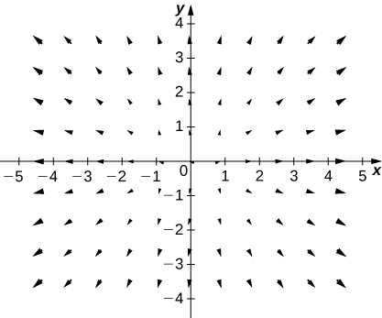

7. **[T]** 

Answer:

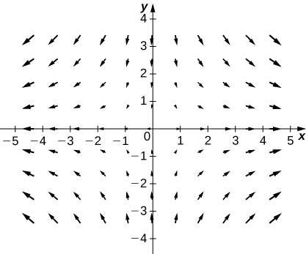

9. **[T]** 

Answer:

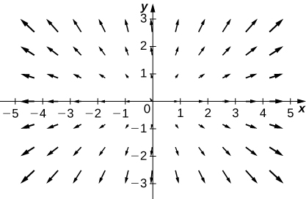

11. **[T]** 

Answer:

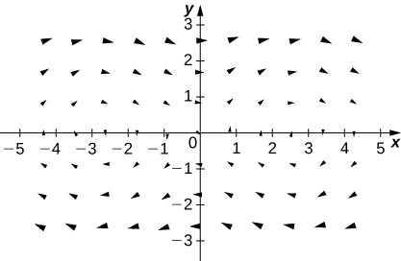

13. **[T]** 

**Answer:**

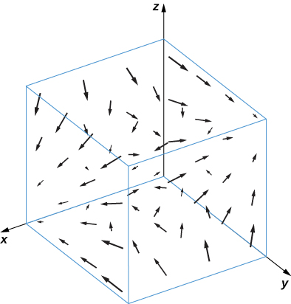

**For the following exercises, find the gradient vector field of each function *f*.**

15. 

Answer: 

17. 

Answer: 

19. 

Answer: 

21. What is vector field  with a value at  that is of unit length and points toward 

Answer: 

**For the following exercises, write formulas for the vector fields with the given properties.**

23. All vectors point toward the origin and have constant length.

Answer: 

25. Give a formula  for the vector field in a plane that has the properties that  at  and that at any other point  **F** is tangent to circle  and points in the clockwise direction with magnitude 

Answer: 

27. Find a formula for vector field  given the fact that for all points  **F** points toward the origin and 

Answer: 

**For the following exercises, assume that an electric field in the *xy*-plane caused by an infinite line of charge along the *x*-axis is a gradient field with potential function** **where  is a constant and  is a reference distance at which the potential is assumed to be zero.**

29. Show that the electric field at a point in the *xy*-plane is directed outward from the origin and has magnitude where 

Answer: 

**A *flow line* (or *streamline*) of a vector field  is a curve  such that  If  represents the velocity field of a moving particle, then the flow lines are paths taken by the particle. Therefore, flow lines are tangent to the vector field. For the following exercises, show that the given curve  is a flow line of the given velocity vector field **

31. 

Answer: 

**For the following exercises, let   and  Match F, G, and H**

**with their graphs.**

33.

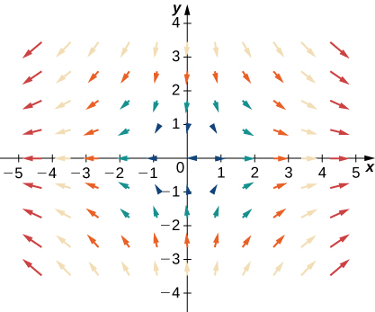

Answer: **H**

**For the following exercises, let   and  Match**

**the vector fields with their graphs in **

1. 
2. 
3. 
4. 

35.

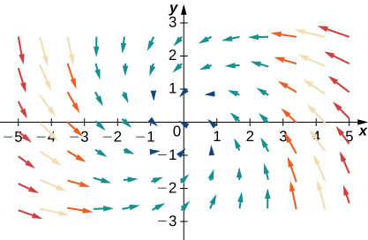

Answer: d. 

37.

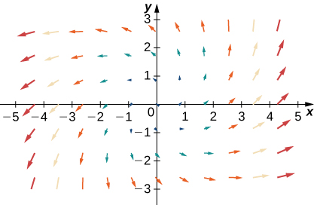

Answer: a. 

This file is copyright 2016, Rice University. All Rights Reserved.